Bring a Lawmaker into Your School or Center!

Without community support, early childhood education cannot grow. Inviting a lawmaker or local advocate into your school or center gives respected members of the community—including the families of children you serve—an opportunity to stand in support of early childhood professionals as they start their workday. It is a powerful way to show the broader public that there is support for early childhood educators and the services they provide.

When you invite lawmakers or advocates with influence into your center, you open the door to deeper understanding of early childhood education issues—and gain new allies.

If you would like to host a lawmaker at your early childhood education setting, here are a few guidelines:

1. Send Invitations
- Consider which individual you want to invite. The invitee could be an elected official, prominent educator, business leader or media personality who is in a position to advocate for public funding for early learning.
- Feel free to use the draft invitation letter below.

2. Make Advance Preparations
- Discuss with your guest how long their visit will be.
- Prepare materials for your guest that include information about your program, the role of the early educator in promoting children’s development as well as information on compensation and public funding issues.
- Local focus: Make May 1 your own by highlighting unique aspects of compensation or education funding—such as increasing the minimum wage or increasing child care subsidies—that affect your community.
- Finally, alert the media about the event to bring more attention to the issues.

3. The Walk-In
- Take pictures!
- Consider having your guest read to your students or sing a song with them.
- Explain some of the routines and activities that make up a day at your early learning setting.

4. Follow up
- After the visit, send a thank-you email to your visitor.

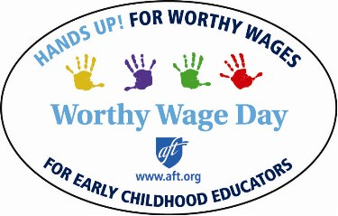

Sample Invitation

Dear ______________,

We represent a group of educators, students, parents and community allies who care deeply about the quality of education our young children receive in [name of county/city/town], and we are part of a national effort to ensure that all children— including those in pre-K and child care—have access to the education they deserve.

High-quality early childhood programs are essential to the well-being of our children, their families and our community. These programs are crucial to preparing children for school, but they are chronically underfunded: Children lack access to the programs, and many early childhood educators live on poverty wages. We, as part of a national movement to advocate for high-quality early childhood programs and a living wage for educators, are demanding a change.

Would you like to help us by visiting our early learning program on May 1? By visiting, you’ll show that you’re a part of the fight for revenue and the political will necessary to ensure families have access to pre-K and child care they can afford, and that early educators have the wages they need to support themselves and their families.

May 1 is Worthy Wage Day, which ushers in a week of activism for educational justice. We hope you will make a commitment to visit our early childhood program and to support access to early learning and worthy wages for early childhood educators.

Thank you for your consideration. We look forward to hearing from you.

In unity,

