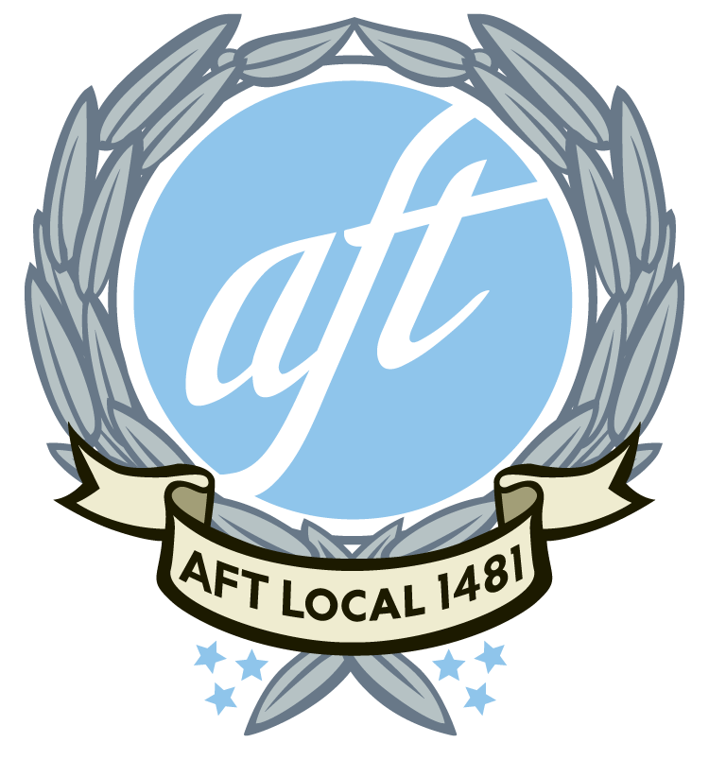 | AFT 1481 Outreach: February “Building Our Power”

ONE: Introduction
Hello, my name is _______________________ from our union, AFT 1481. We’re checking in with each member to...
- have your most current info [Show list & update]
- hear about any issues we should know about [Take notes]
- share the latest about what our union is working on

TWO: Then explain what AFT 1481 is working on right now...
We’re working to build power in our union. We’re
- ...reaching out to each member.
- ...growing our site teams to support our Site Reps at each school
- ...developing ties with our communities to fight for decent housing and living wages
- ...hosting a conference on Public Education, which will include:
- Tom Ammiano opening for keynote speaker Jeff Duncan-Andrade
- 14 different breakout sessions including info about
  - Working with EL students
  - The lack of funding for North San Mateo County schools
  - The housing crisis and how it affects our members, students and families
- Town hall forum to address workforce challenges in schools across the county with Jerry Hill, County Superintendent Anne Campbell, and County Supervisor David Pine.

Here is a flyer with more details.

TWO (1st ASK) Will you join us at the conference on Saturday, March 19th?
YES Thank you! I’ll register you and you’ll get a reminder by email.
NO This is our big, public event of the year. In order to make this conference a success, we really need as many people to attend as possible. Are you sure you can’t attend?
FOUR We’re also involved in community coalitions fighting for housing rights and living wages with FairRents4Pacifica & 4 North County in Daly City.

FIVE (2nd ASK) Are you interested in learning more about this work?
YES Great! Sergio will follow up with you to share more info.
NO No problem.

CLOSE Thanks for your time. We’ll keep you updated on union business. If you have any questions or concerns, please don’t hesitate to contact us.

