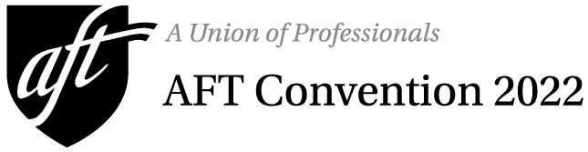

Meal Ticket Order Form
Deadline: Friday, July 1
No tickets will be sold in Boston!

Purchaser/Contact Name

Affiliate/Local Name |  |  |  |  |  |  |  | Local Number
Home Address |  |  |  |  |  | City, State, ZIP
Email |  |  |  |  | Cell |  |  |  | Work

ordering and payment:
- Credit card (Mastercard or Visa only)
Email completed form with payment information to mealtix@aft.org.
- Check or money order (payable to AFT)
Mail completed form and payment to: AFT Membership / Meal Ticket Sales
555 New Jersey Ave. N.W., Washington, DC 20001

IMPORTANT INFORMATION:
- All meal functions will take place at the Boston Convention and Exhibition Center.
- Pick up prepaid tickets at the registration counter marked “Meal Tickets” in Hall B1.
- The group contact must pick up all tickets. Tickets will be issued only to the person listed above.
- No tickets will be available for purchase in Boston. Orders must be received by Friday, July 1.

Meal Function | Price | No. of Tickets | Total
AFT Public Employees Jim McGarvey Breakfast  Friday, July 15, 7:30 a.m. – plated breakfast | $25 per person  advance purchase only
AFT PSRP Breakfast  Friday, July 15, 7:30 a.m. – buffet breakfast | $25 per person  advance purchase only
AFT Nurses and Health Professionals Breakfast  Friday, July 15, 7:45 a.m. – plated breakfast | $25 per person  advance purchase only
AFT Human Rights Luncheon  Friday, July 15, 12:30 p.m. – plated luncheon | $35 per person  advance purchase only
AFT Women’s Rights Breakfast  Sunday, July 17, 7:30 a.m. – plated breakfast | $25 per person  advance purchase only
Total Amount Due

Payment Information (see ordering and payment options above)
 | Check/money order enclosed (made payable to AFT) in amount of |  |  |  |  |  |  | $ |  | Check No.
 | Charge my Mastercard |  |  |  |  |  | Charge my Visa
 | Name (as it appears on card)
 | Billing Address
 | Credit Card Number |  |  |  |  |  |  |  | Expiration Date
 | Signature of Cardholder

